**AWS re/Start Collaborating Organization (CO) Portal Multi-Factor Authentication (MFA) Use Guide**   
*Effective Date: February 28, 2024*

AWS re/Start Collaborating Organization (CO) Portal users logging into the AWS re/Start CO Portal are required to authenticate via Multi-Factor Authentication (MFA). This document contains authentication steps and best practices.

Step 1

Go to the AWS re/Start CO Portal login page at: <https://www.awsrestartprogram.com> and enter your username and password.[1]

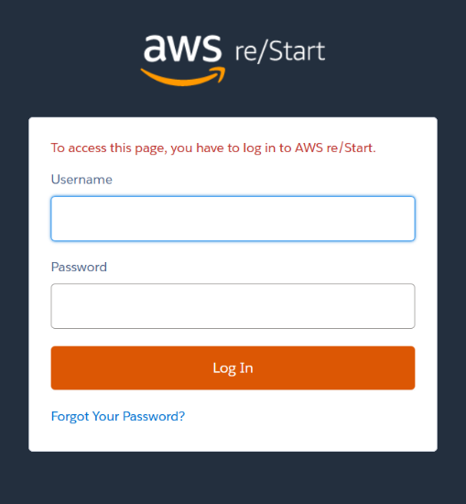

Step 2

An email will be sent to the email address associated with your AWS re/Start CO Portal account. In the meantime, you will see the following “Verification Code” window.

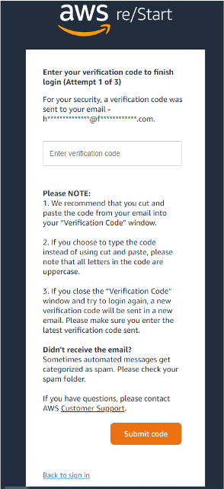

Step 3

Once you receive the code as seen in the example email below, **copy and paste** the code from the email into the “Verification Code” window. If you choose to type the code instead of using copy and paste, please note that all letters in the code are **uppercase.**

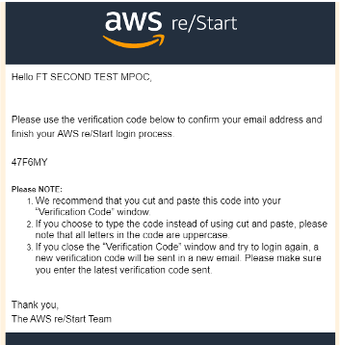

When the user successfully follows the above steps, you will be routed to the AWS re/Start CO Portal.

Troubleshooting

If the user fails to verify on the first attempt, the text in red below will appear in the “Verification Code” Window. You will receive a different code each time you log in and **you must use the latest code sent**.

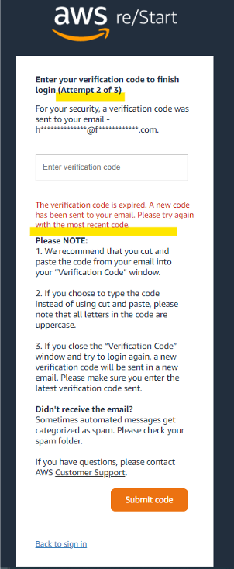

The codes are active for 30 minutes. If you have not entered the code within 30 minutes, you will need to go back to Step 1 to log in and get a new code.

After three failed login attempts, the user will be locked out and must contact AWS Customer Support through the [online support form](https://support.aws.amazon.com/#/contacts/aws-restart).

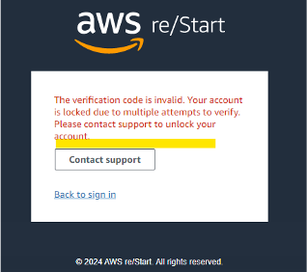

**Questions or problems?** Please open a case with AWS Customer Support through the [online support form](https://support.aws.amazon.com/#/contacts/aws-restart). After submitting the form, you will receive an email from [aws-cs-restart-form@amazon.com](mailto:aws-cs-restart-form@amazon.com) asking you to reply from your email address. This is a necessary Security step which validates that you are the person making the support request. *Please respond to this Security prompt with an email response so that your case can be actioned.*

1. *Note that your username is the email address associated with your AWS re/Start CO Portal account when it was created followed by “.awsrestart” . Users associated with multiple COs will have a unique username associated with each CO.*